Experiment No. 1

Title
Cloud Account Setup and Services Overview in Amazon Web Services (AWS)

Aim
To create an Amazon Web Services (AWS) account and explore the AWS Management Console and its major cloud services.

Objective
After completing this experiment, students should be able to:
- Understand AWS Cloud.
- Create an AWS account.
- Sign in to the AWS Management Console.
- Identify major AWS services.
- Navigate through the AWS Dashboard.

Introduction (Theory)
Amazon Web Services (AWS) is the world's leading cloud computing platform developed by Amazon. Instead of purchasing expensive servers, organizations can rent computing resources over the internet.
AWS provides more than 200 cloud services, including:
- Computing
- Storage
- Databases
- Networking
- Artificial Intelligence
- Machine Learning
- Security
- Analytics
These services follow a pay-as-you-go pricing model.

Advantages
- No hardware purchase
- Highly scalable
- Secure
- Reliable
- Global availability
- Cost effective

Software Requirements
- Windows 10/11
- Google Chrome or Microsoft Edge
- Internet Connection
- Email ID
- Mobile Number
- Debit/Credit Card (required for AWS account verification, even for Free Tier)

Procedure

Step 1
Open your browser.
Go to
https://aws.amazon.com

Step 2
Click
Create an AWS Account

Step 3
Enter
- Email Address
- Password
- AWS Account Name
Click Continue

Step 4
Choose
Personal Account
(Students can also use Business Account if instructed.)

Step 5
Enter
- Name
- Address
- Phone Number
Accept the agreement.

Step 6
Enter your Debit/Credit Card details for identity verification.
(A small temporary verification charge may be applied and later reversed.)

Step 7
Verify your mobile number using the OTP.

Step 8
Select
Basic Support (Free)

Step 9
Login to the AWS Console.
You will see the AWS Management Console.

AWS Console Overview
Students should become familiar with these sections:

Search Bar
Used to search AWS services quickly.
Example:
- EC2
- S3
- Lambda

Services Menu
Contains all AWS services grouped into categories.
Examples:
Compute
- EC2
- Lambda
- Elastic Beanstalk
Storage
- S3
- EBS
- EFS
Database
- RDS
- DynamoDB
Networking
- VPC
- Route 53
Security
- IAM
- KMS
Analytics
- Athena
- EMR
Machine Learning
- SageMaker

Region Selection
Example:
Mumbai
Singapore
US East (N. Virginia)
Students should understand that resources are created within a selected AWS Region.

Billing Dashboard
Displays:
- Usage
- Estimated Cost
- Free Tier Usage

Account Settings
Contains
- Profile
- Security Credentials
- MFA
- Password Settings

Services to Explore
Students should open each service briefly.

EC2
Virtual servers in the cloud.

S3
Cloud object storage.

IAM
User and permission management.

VPC
Virtual private network for AWS resources.

RDS
Managed relational database service.

Lambda
Run code without managing servers.

CloudWatch
Monitoring and logging service.

SNS
Notification service.

Expected Output
Students should successfully:
- Create an AWS account.
- Log in to the AWS Management Console.
- Locate major AWS services.
- Understand the purpose of common cloud services.

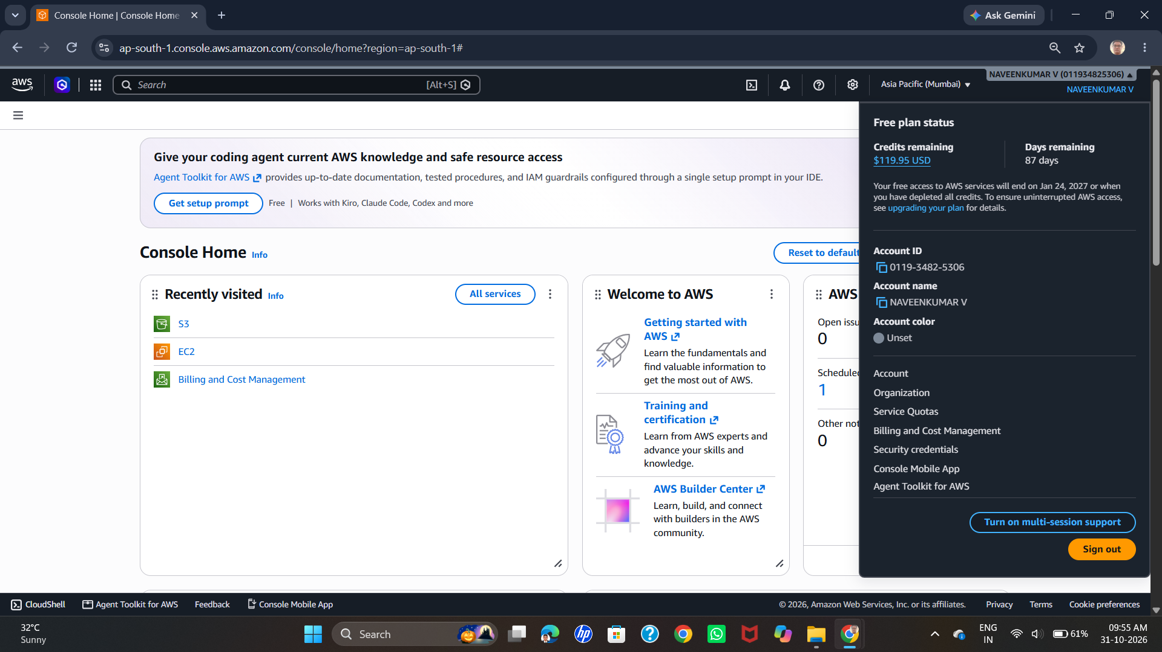

Result
Thus, the AWS account was created successfully, and the AWS Management Console and major cloud services were explored.

